32K Linear Datapacks

32K Linear datapacks were made, as shown here:

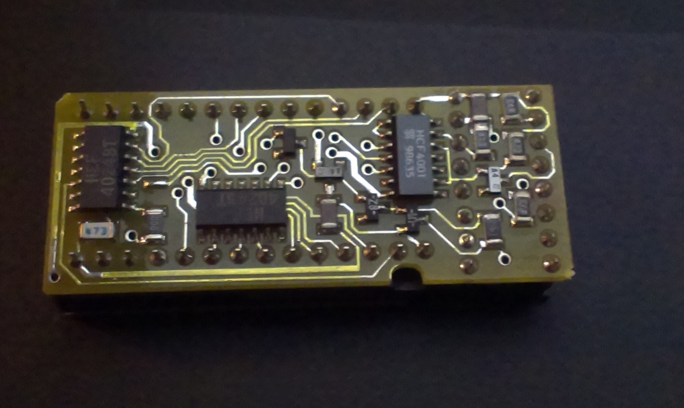

Later, 32K paged packs were made, but the PCB layout was almost identical:

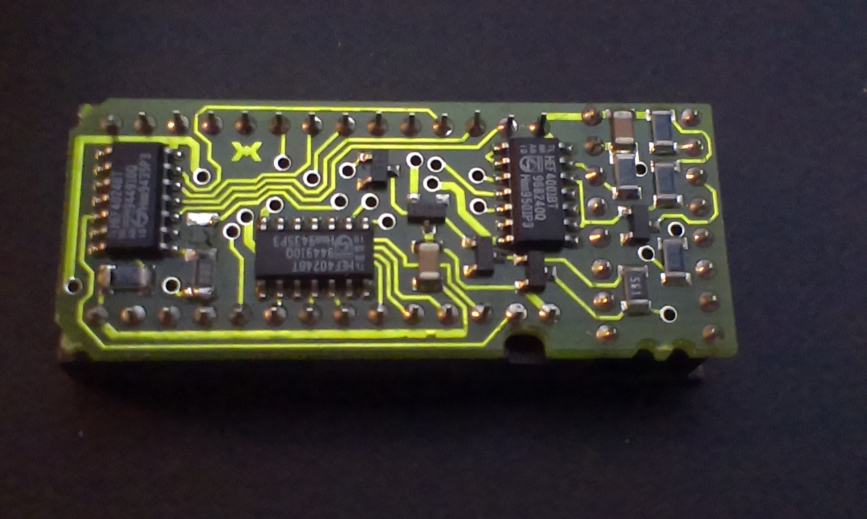

The PCB layout actually allows for either a linear or paged addressing scheme as the only change needed is to change the source of the clock to the second address counter. If that clock comes from the top address bit of the first counter then the pack is linear, and the two counters are connected to make one large counter. If the clock to the second counter is from the PGM signal then it increments when the organiser sends a ‘page increment’ command, and the pack is then page addressed. This can be done by putting a zero ohm resistor either in the Red position or the green position:

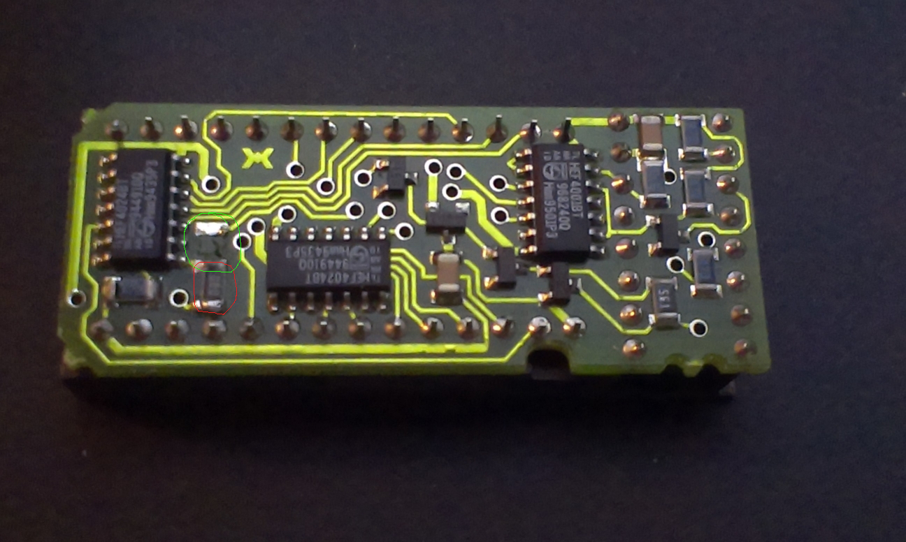

Link in red position: Linear addressing
Link in green position: paged addressing

